Visualization Project:

Interactive Dashboard for Tuberculosis (TB) Data (1990–2013, with optional 2024 update)

By
Surafel Asfawosen

📊 TB Interactive Dashboard Documentation
🔧 Data Preparation & Cleaning (Final Version)
The TB dataset covering the years 1990 to 2013 (with optional 2024 update) was first loaded into Power Query Editor in Power BI. The following preprocessing steps were performed:
- Column Renaming:
For clarity and consistency, columns were renamed (e.g., "Incidence rate per 100,000" → "Incidence per 100k", "Total Cases" → "Total TB Cases").
- Data Types Converted:
Ensured proper column types:
  - "Year", "Population", "Total TB Cases", "TB Deaths", "HIV-TB Deaths" → Integer
  - "Incidence per 100k", "Mortality per 100k", "Case Detection Rate (%)" → Decimal
- Handling Missing Values:
Missing data was imputed using context-appropriate methods:
  - Mean Imputation was applied to numerical rate-based variables:
    - " Case Detection Rate (%)"
  - Mode Imputation was applied to the following:
    - " HIV-TB Incidence per 100k" (due to skewed distribution)
- Feature Selection: The following features were retained for analysis based on their importance in evaluating TB trends and outcomes:
  - "Total TB Cases"
  - "TB Deaths"
  - "Incidence per 100k"
  - "Mortality per 100k"
  - "HIV-TB Incidence per 100k"
  - "HIV-TB Deaths"
  - "Case Detection Rate (%)"
  - "Population"

📈 Visualizations & Dashboard Features

The interactive dashboard includes the following key components:
✅ Slicers (Interactive Filters)
- Year (1990–2013; 2024 for updated dataset)
- Country
- Region
These slicers allow users to filter the dashboard and explore trends for specific years, regions, or countries.

✅ KPIs (Key Performance Indicators)
- Total TB Cases (sum)
- TB Incidence per 100,000 population
- Sum of Tb-deaths by year
These KPIs dynamically respond to slicer inputs (year, country, region), providing quick insight into the TB burden.

✅ Visualizations
- Line Chart:
  - X-axis: Year
  - Y-axis: Total TB Cases
  - Legend: Region
  - Purpose: To observe and compare trends in TB cases across different regions over time.
- Bar Chart:
  - X-axis: Country
  - Y-axis: TB Deaths (sum)
  - Legend: Region
  - Purpose: To compare TB mortality by country and region

- Pie Chart:
  - Legend: Region
  - Values: HIV-TB Deaths (sum)
  - Purpose: To display proportional distribution of HIV-related TB deaths by region.
- Additional Charts:
  - Sum of TB Deaths by Year
  - Trend Forecast Line (1990–2024) using Power BI's forecasting feature to predict future TB cases.
📅 Forecasting & Comparative Analysis
- Applied Power BI's forecasting tool on the TB case trend line to predict future cases for the next 10 years.
- Integrated updated 2024 TB-data from Kaggle to compare real values with predicted trends.
🧠 Data Storytelling
The final dashboard includes written insights that summarize:
- Past: TB trends and major changes from 1990 to 2013.
- Present: TB status in 2013, the final year in the original dataset.
- Future: Predicted TB cases up to 2024 and strategic recommendations for reducing incidence.
Page 1
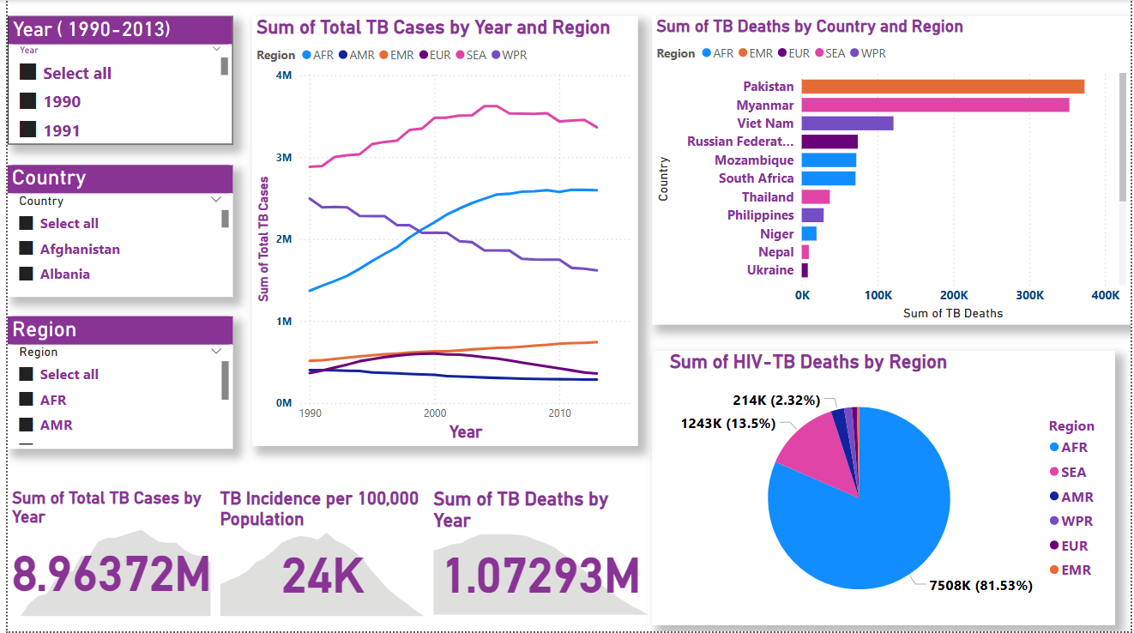

Page 2

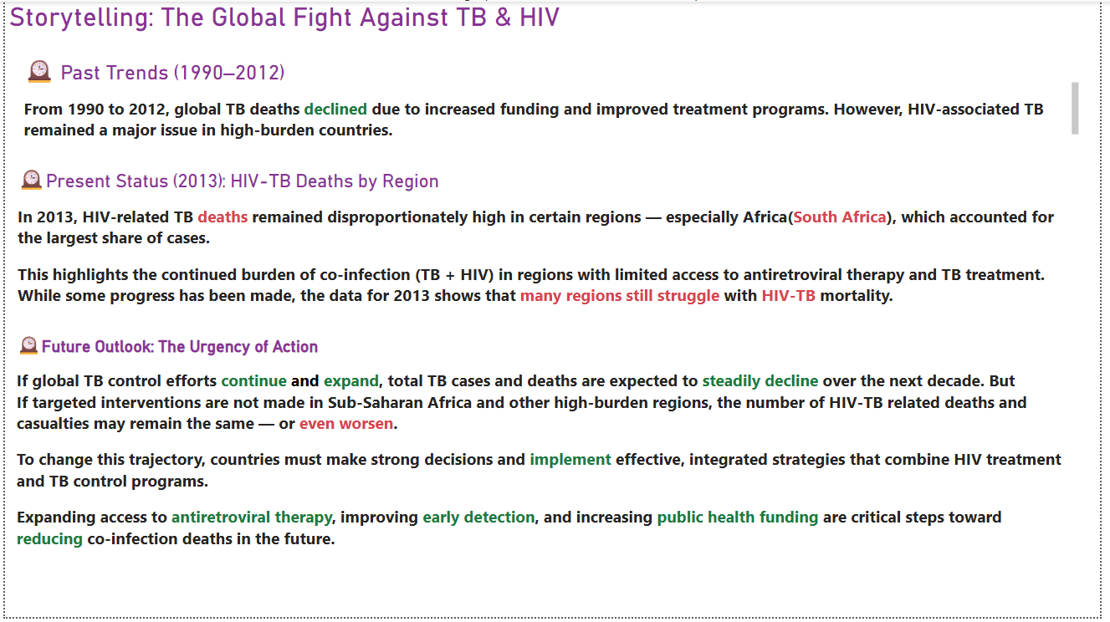
Page 3
